Using The Vortex Game Launcher
By GHz (ghz@project-vortex.com)
Last updated 10/5/2009

A new addition to Vortex is the Vortex Game Launcher (VGL). One of the main complaints among new players of Quake 2 and Vortex is that getting started is quite difficult. The Quake 2 user interface is rather primitive compared to modern standards. Couple this fact with Vortex’s myriad ability commands, and it’s easy to become quite frustrated before ever playing a single game.

Fortunately, the VGL makes life easy for you by hiding all of the boring details of configuration with a modern user interface. It’s included with the full install of Vortex. When you run the program for the first time, you will be presented with the Settings menu.

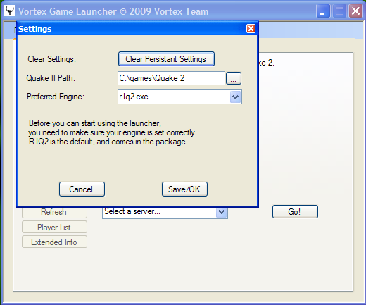
* Figure 1: First run, settings screen

The Quake II Path should be pointed to your Quake 2 or Vortex install directory. If it isn’t, just click on the ellipse (the 3 dots to the right of the path text box) and point it to the right location. By default, Vortex uses R1Q2, but an advanced user might want to change it to another supported engine. We recommend you keep it at the default setting unless you know what you are doing. When you are done, click Save/OK to close the menu and move to the main screen.

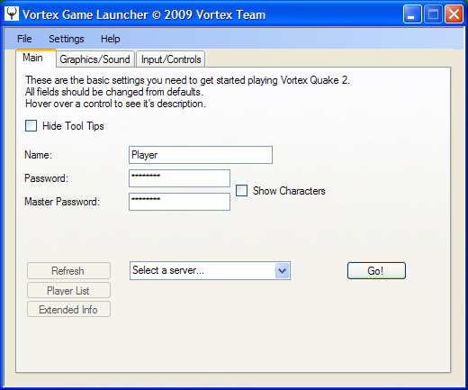
* Figure 2: Main tab

Once the settings menu is out of the way, the Main tab will be exposed. If you hover your mouse over anything here, a useful tooltip/bubble will appear that explains the item in more detail. You can disable this feature by clicking on the Hide Tool Tips box.

The Name text box contains your character name. You must change this to something besides the default value, as your name must be unique to the server. Every character that you create must have a unique name. For example, if set your name to “Bob The Builder”, then join the server and start a new engineer, then you must specify “Bob The Builder” every time you want to play as your engineer. You can’t change your character name once it is created. If you try to do this, you will be asked to create a new character when you join the server. Thus, the name you specify becomes your character.

The Password text box contains the password that must be used to access your character. Although (as of this writing) it is possible to create a character with no password, we don’t recommend it. With no password, your character may be stolen, and your recovery options may be limited. You can change your password in-game by typing ‘set vrx_password newpass u’ in the game console (accessed via the ~ tilde key).

The Master Password text box contains a write-once password that can be used to access your character in the event that you forget your main password. For security reasons, we recommend that this password is different from your main password, unless you plan to never share your character and/or password. Once the master password is set, it cannot be changed.

The combo box (pull-down menu with the default text: “Select a server…”) at the bottom of the tab is used to select a game server to play on. By default, only official Vortex game servers are listed. We strongly recommend you only connect to official servers. Official servers have a regular admin presence, get frequent game updates, and you can ensure the safety and availability of your character data. Click on the Refresh button to the left of the combo box to update the server data. Click on the Player List button to get a list of players currently on the server (including scores and ping info). Click on the Extended Info button to show a list of extended server parameters.

When you are ready to join the server and begin playing, click on the Go! button to launch the game and join the server. However, we strongly recommend that you continue reading before doing so. There are a few more things we need to cover!

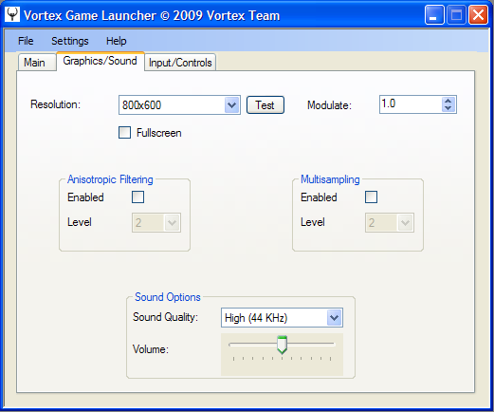
* Figure 3: Graphics/Sound tab

The Graphics/Sound tab contains basic graphics and sound settings. The Resolution combo box contains a list of supported game resolutions. We recommend you change this to the highest native resolution that your computer supports (usually your desktop resolution). It’s also best to click on the Fullscreen check-box so that the game does not launch in windowed mode. The Modulate value determines how bright the game is. Click the arrows to the right to change this value to a higher or lower value (3.0 is recommended). Anisotropic Filtering and Multisampling affect image quality (e.g. smoothing of lines). Leave these settings alone unless you understand what they mean. Sound Quality should be left at the 44 KHz (high quality) value.

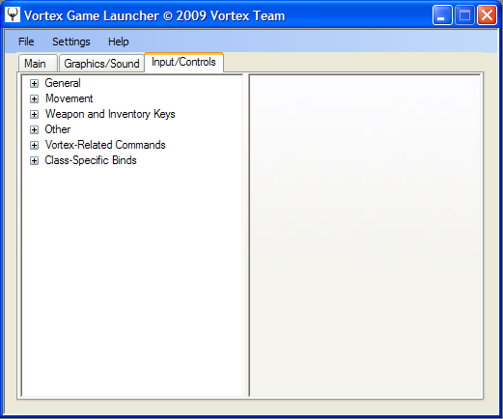
* Figure 4: Input/Controls tab

The Input/Controls tab is where you will configure your keys and controls. It allows you to define how you will move and interact within a Vortex game. Settings are grouped in a hierarchical structure, with six broad categories at the top. The General category contains movement settings (e.g. mouse speed), while the Movement category contains actual movement keys (e.g. press X to jump). The Weapon and Inventory Keys category contains keys for changing weapons and weapon modes, handling inventory, and attacking.** The Other category contains keys for showing the score board and keys for communication. The Vortex-Related Commands are generic Vortex commands for using special inventory items and bringing up various menus within the game. Finally, the Class-Specific Binds contains all the ability action keys grouped by class.

** There are several important settings under the Weapon and Inventory Keys category that must be set: Inventory, Use Item, Next Item, and Previous Item. They are used for Vortex’s various menus, so make sure the keys are set and you are familiar with them!

To navigate the structure and configure these keys, you will have to expand the “tree” structure of these categories by clicking on the plus (+) sign to the left of each category. Below the first level of categories, you will either find a sub-category that you further expand, or you will find a command that must be bound to a key. Click on a sub-category to view its description, or click on a command to view its description and available actions. Once you have selected a command, click on the Bind button to associate the command with an action (e.g. a key press or a mouse click). This will cause a small window to pop-up. You can either press a key on your keyboard, or click in the window using your mouse. Press ESC (escape) to abort/cancel binding a key.

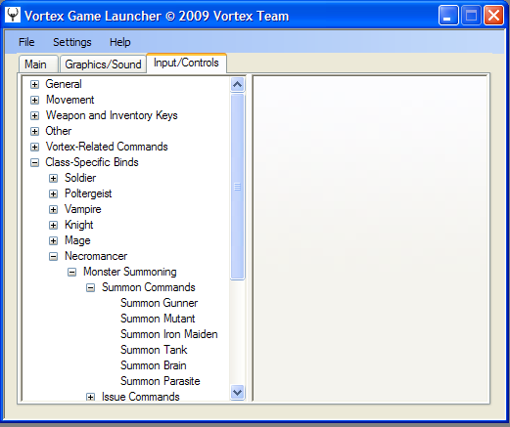
* Figure 5.1: Expanded “tree” or hierarchical menu structure

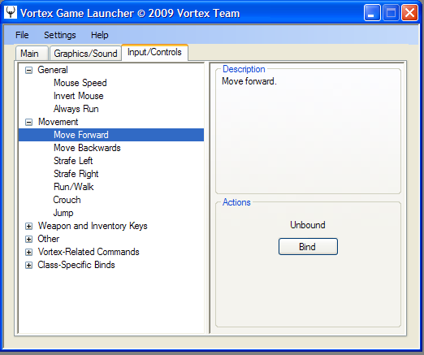
* Figure 5.2: Command selected showing the Description and Actions boxes

Don’t worry about trying to set a key for every single command. You would run out of keys long before that! The most important thing is to do the following:

- Make sure you set your name, password, and master password in the Main tab.
- Set your preferred resolution (probably the same as your desktop resolution) and gl_modulate (brightness) value in the Graphics/Sound tab.
- Configure or verify all the keys under the General, Movement, Weapon and Inventory Keys, Other, and Vortex-Related Commands. Pay particular attention to the inventory commands that are used for managing menus. You don’t need to configure a key for all of the menus, but you at least should set a key for the Vortex Menu command (since all other menus can be accessed from this one menu). Don’t forget to bind a key for secondary fire, as this is used for many weapons.
- Configure Class-Specific Binds only for abilities that you know you will use for your character. If this is your first time with Vortex, you can safely ignore all of these commands until after you have gained a level and explored the upgrade menu. Many abilities are passive (e.g. Strength) and don’t require a special key. Do your research on what you plan to upgrade (read the abilities guide and look at the website/forums) and then worry about setting your keys.

We hope you enjoyed this guide and look forward to seeing you in the game. Have fun!

